# Aws ASSESMENT

Contents

Aws ASSESMENT 1

1. Create an AWS account 3

2. Create a billing alarm [1$] 3

3. Identity and Access Management [IAM] 3

3.1 Create 3 user groups: HCS-Admins, HCS-Developers, HCS-DevOps 3

3.2 Create 6 IAM users: 4

3.3 Assign users to groups: 4

3.4 Add a tag to all users: HCS-Foundation-Program 5

3.5 Add MFA for users: <Your_name> and Horatiu 5

4. Amazon S3 6

4.1 Create a S3 bucket 6

4.2. Download a picture 6

4.3. Upload apple.png file into your bucket. 6

4.4. Try to open the object’s URL. 7

4.5. Enable Versioning for <yourfullname>-hcs-foundation-program 8

4.6. Download another picture with the APPLE logo 9

4.7. Upload the new apple.png file into your bucket. 9

4.8. List all the apple.png versions 9

4.9. Delete apple.png object (the new object) 10

4.10. Expend Versions 11

4.11. Restore the old apple.png image 11

4.12. Permanently delete all objects 12

4.13. Enable replication 12

4.14. Download a picture with the IBM logo 13

4.15. Upload ibm.png file 13

4.16. Create a life cycle policy 14

6. Amazon EC2 15

6.1 Create three EC2s: 15

6.2 Are servers reachable? Why? 18

From your WorkStation ping Bastion-Server - SUCCESS 18

From your WorkStation ping Web-Server - SUCCESS 20

From your WorkStation ping DB-Server -FAIL? NOOO 21

6.3 Are servers accessible? Why? 21

Connect to Bastion-Server -SUCCESS 21

Connect to Web-Server - SUCCESS 26

Connect to DB-Server from Web-Server – SUCCESS 29

6.4 Reconfigure the SGs : 31

For bastion-server 31

For Web-server 32

For DB-Server: 33

6.5 Retry all the PINGs and Connections: 34

From Bastion-Server ping Web-Server - SUCCESS 34

From Bastion-Server ping DB-Server – SUCCESS 34

From Web-Server ping Bastion-Server -SUCCESS 35

From Web-Server ping DB-Server -SUCCESS 36

From DB-Server ping Web-Server – SUCCESS 36

From DB-Server ping Bastion-Server - SUCCESS 37

Ping www. google.com from Bastion-Server – SUCCESS 37

Ping www.google.com from Web-Server - SUCCESS 38

Ping www.google.com from DB-Server – SUCCESS 38

7. Cloud Watch 39

7.1. Create a CloudWatch Alarm for Bastion-Server 39

7.2. Generate some traffic in order to trigger the alarm. 40

# Create an AWS account

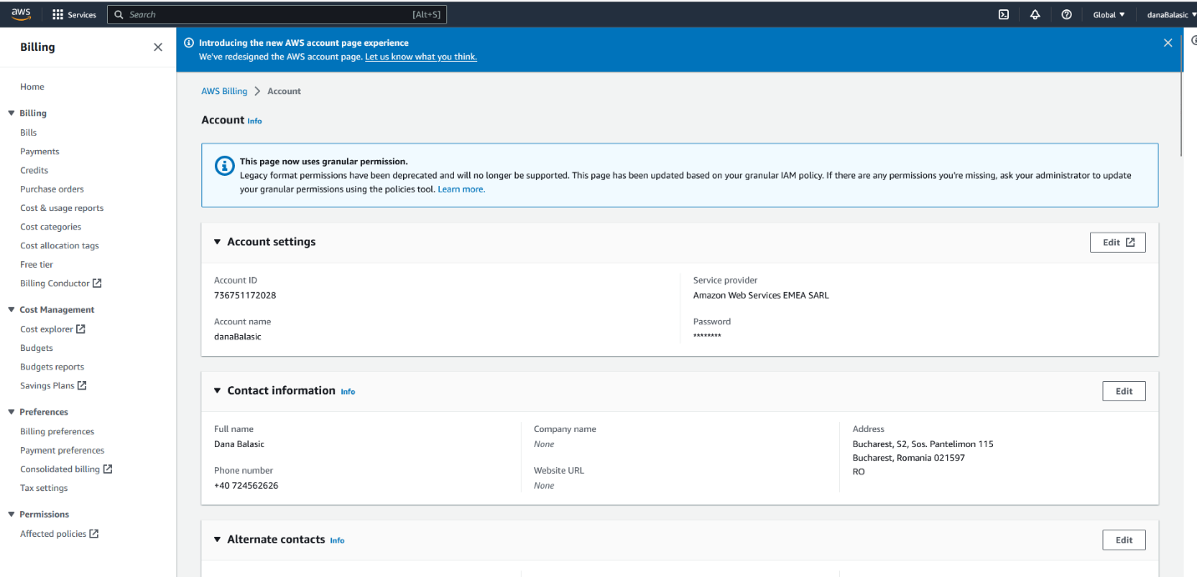

# Create a billing alarm [1$]

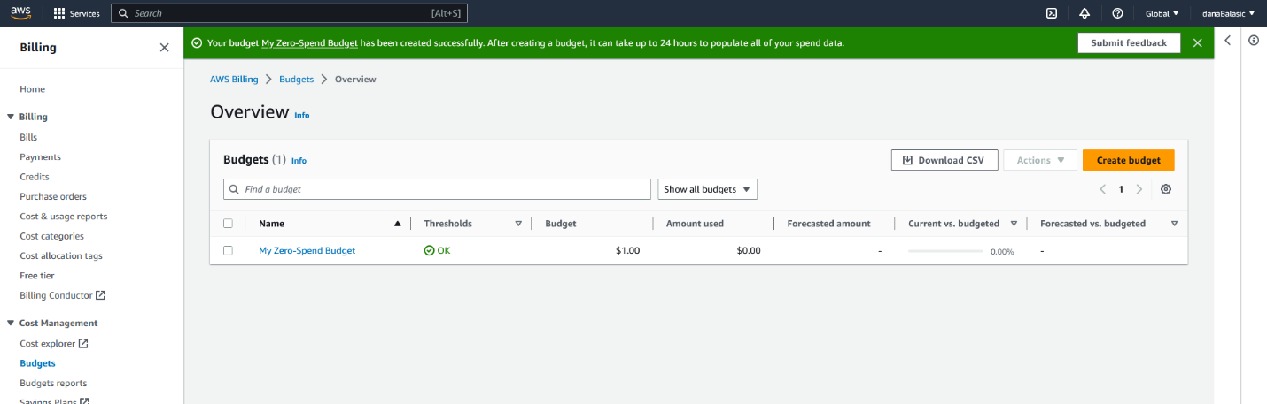

# Identity and Access Management [IAM]

## 3.1 Create 3 user groups: HCS-Admins, HCS-Developers, HCS-DevOps

* I added no policies because it was not specified

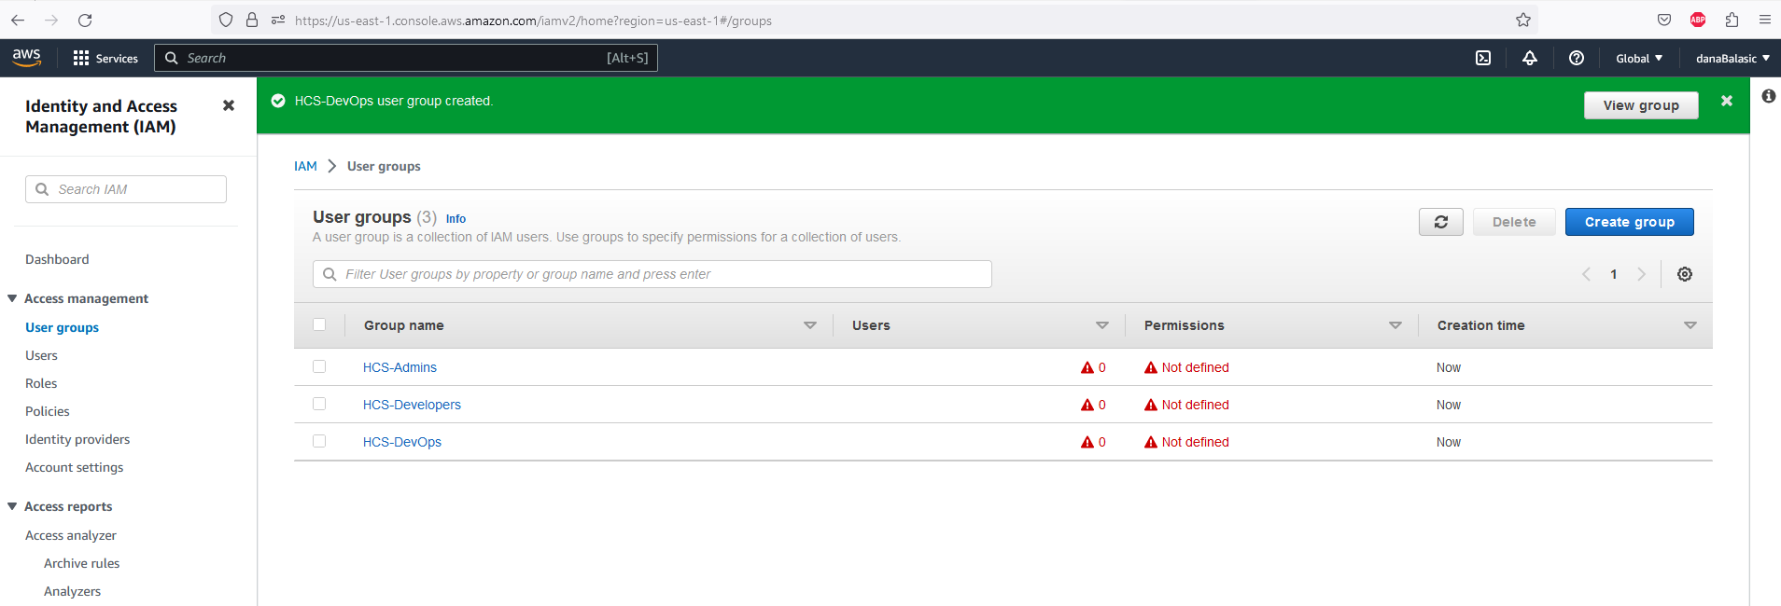

3.2 Create 6 IAM users: David, <Your_name>, Horatiu, Laurentiu, Olivia, Adrian.Note: The users need to have AWS Management Console access and a new password needs to berequested at the next sign-in.

Example for David + tag HCS-Foundation-Program

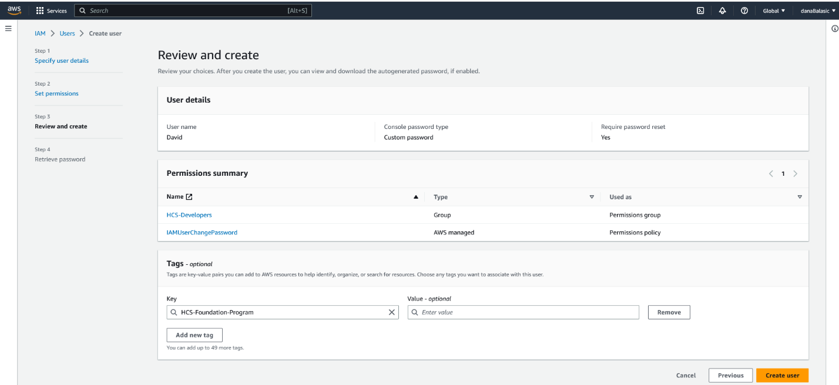

3.3 Assign users to groups:HCS-DevOps group: Laurentiu, OliviaHCS-Developers group: David, <Your_name>, HoratiuHCS-Admins group: Horatiu, Laurentiu

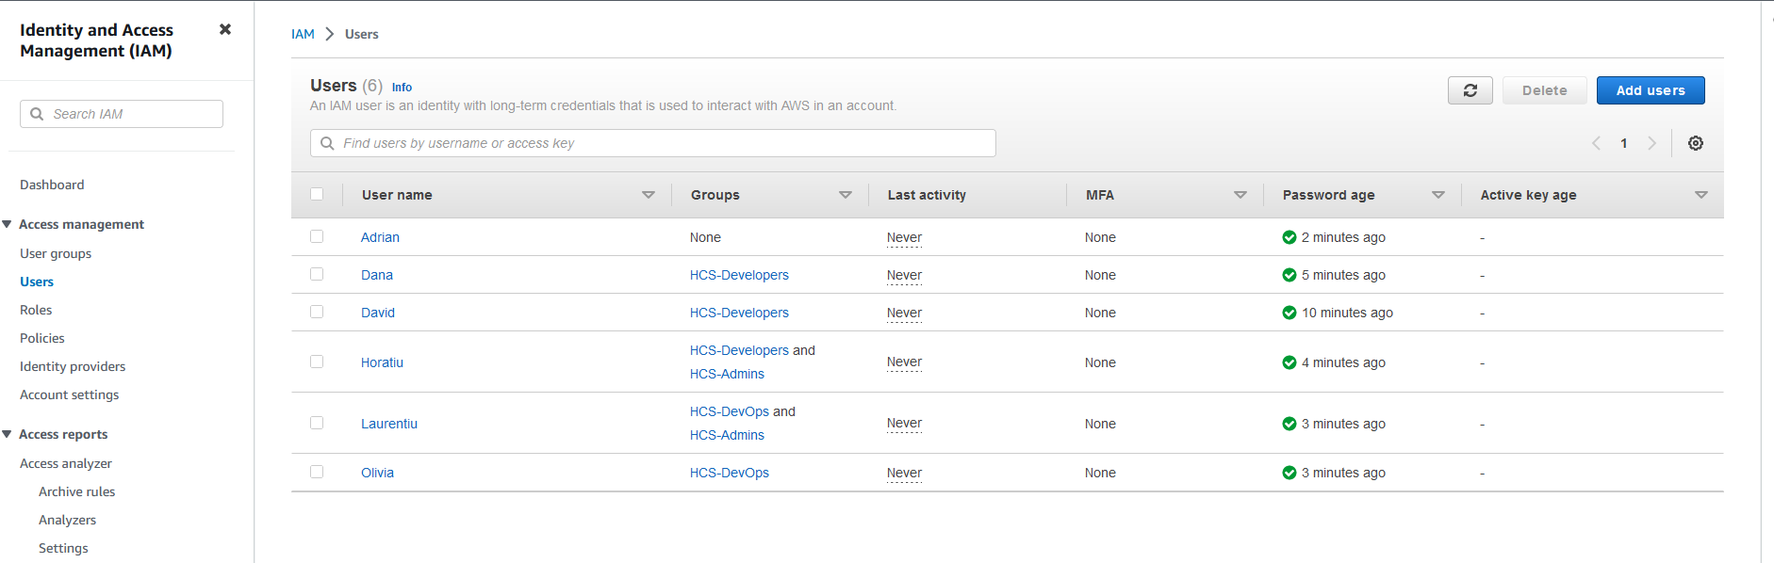

## 3.4 Add a tag to all users: HCS-Foundation-Program

* See example at 3.2 for David

## 3.5 Add MFA for users: <Your_name> and Horatiu

* For Dana I used Autenticator app ( from Microsoft)
* For Horatiu I used IBM Verify

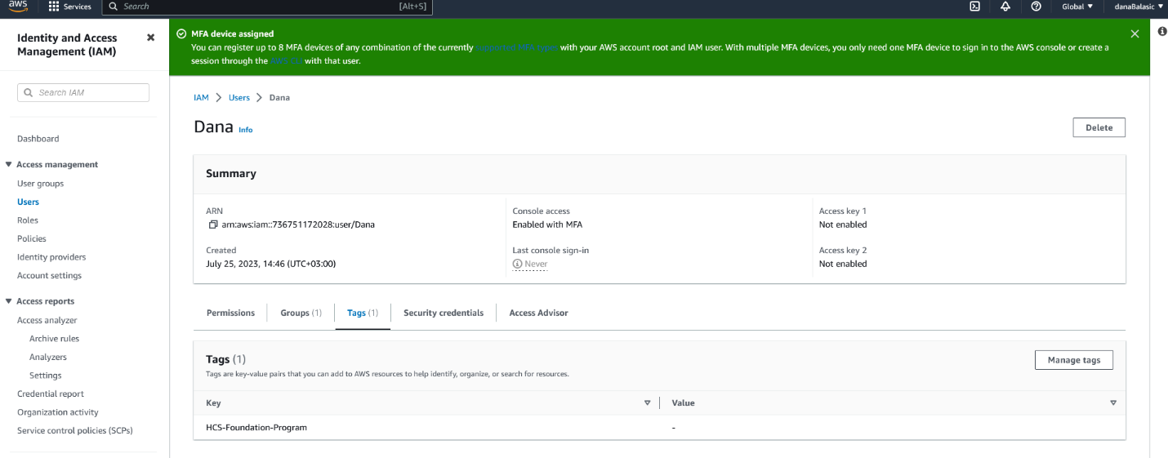

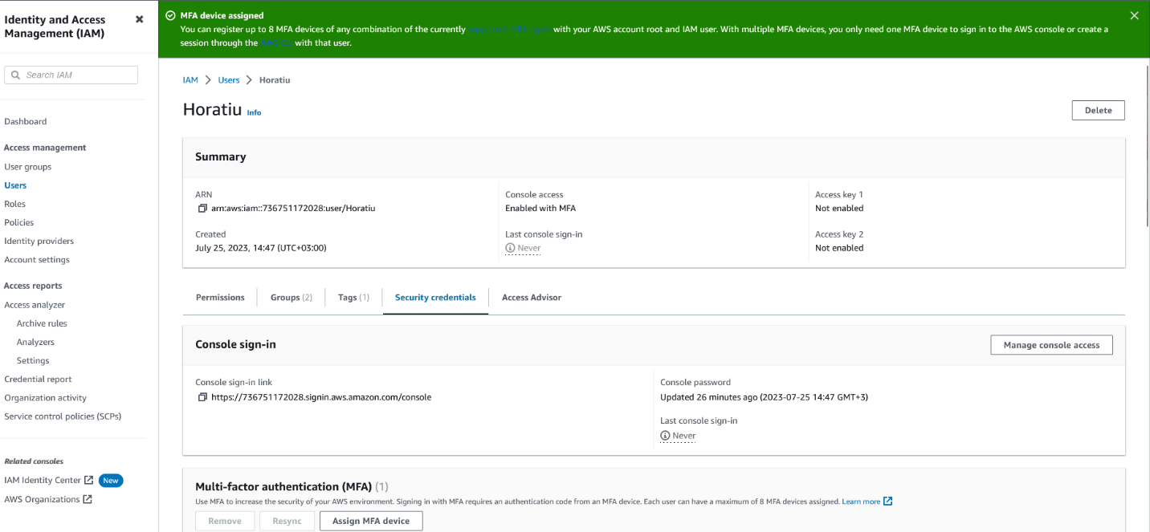

# Amazon S3

* 1. Create a S3 bucket, named <yourfullname>-hcs-foundation-program in us-east-2.Eg: horatiustaicovici-hcs-foundation-program

Note: Bucket – Private, Versioning – Disable, Tag: HCS-Foundation-Program

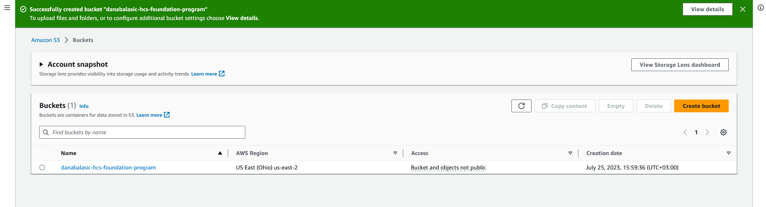

4.2. Download a picture with the APPLE logo (black and white) and name it apple.png

## 4.3. Upload apple.png file into your bucket.

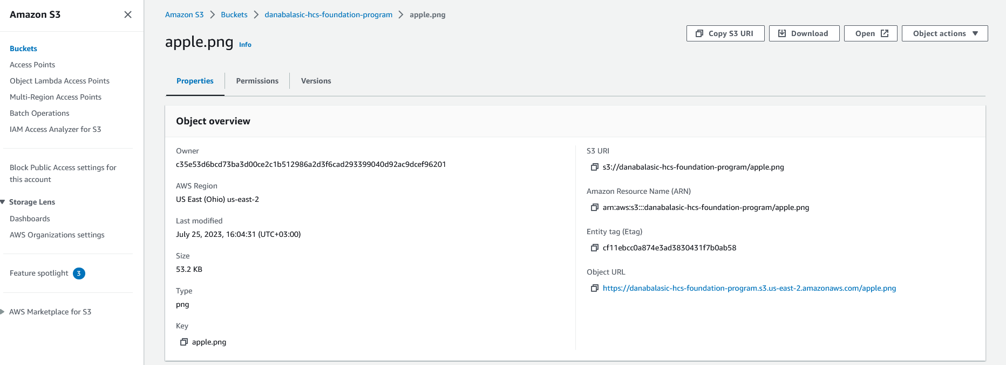

## 4.4. Try to open the object’s URL.

- Accessing this <https://danabalasic-hcs-foundation-program.s3.us-east-2.amazonaws.com/apple.png>

Does not work, even if I am removing the HTTPS

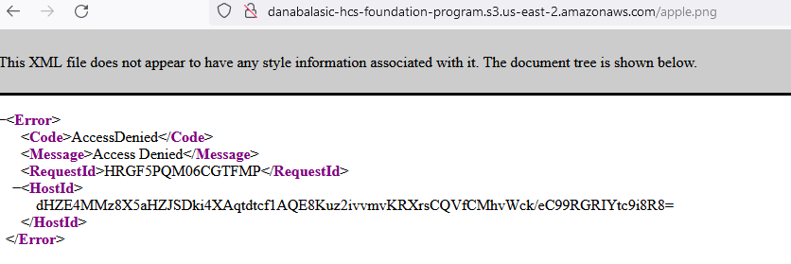

But opening directly works

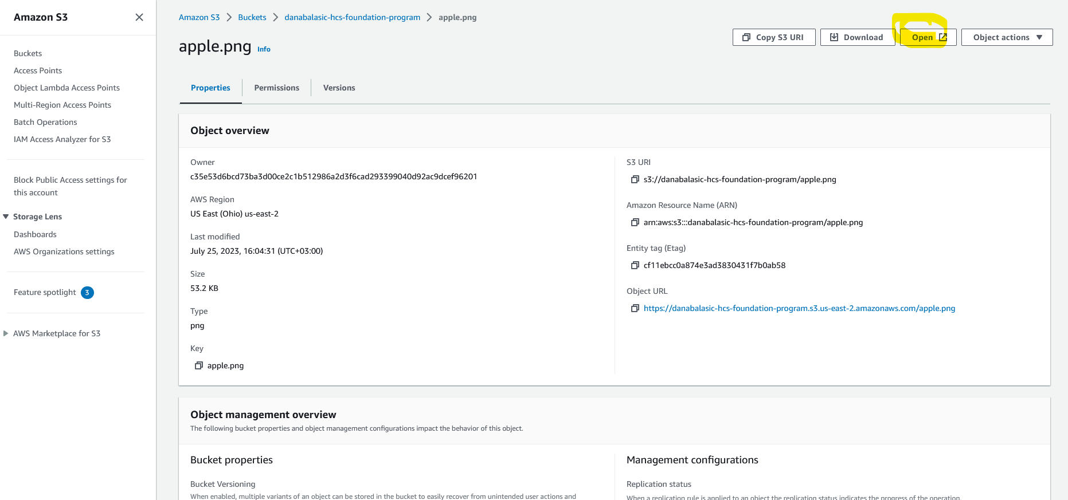

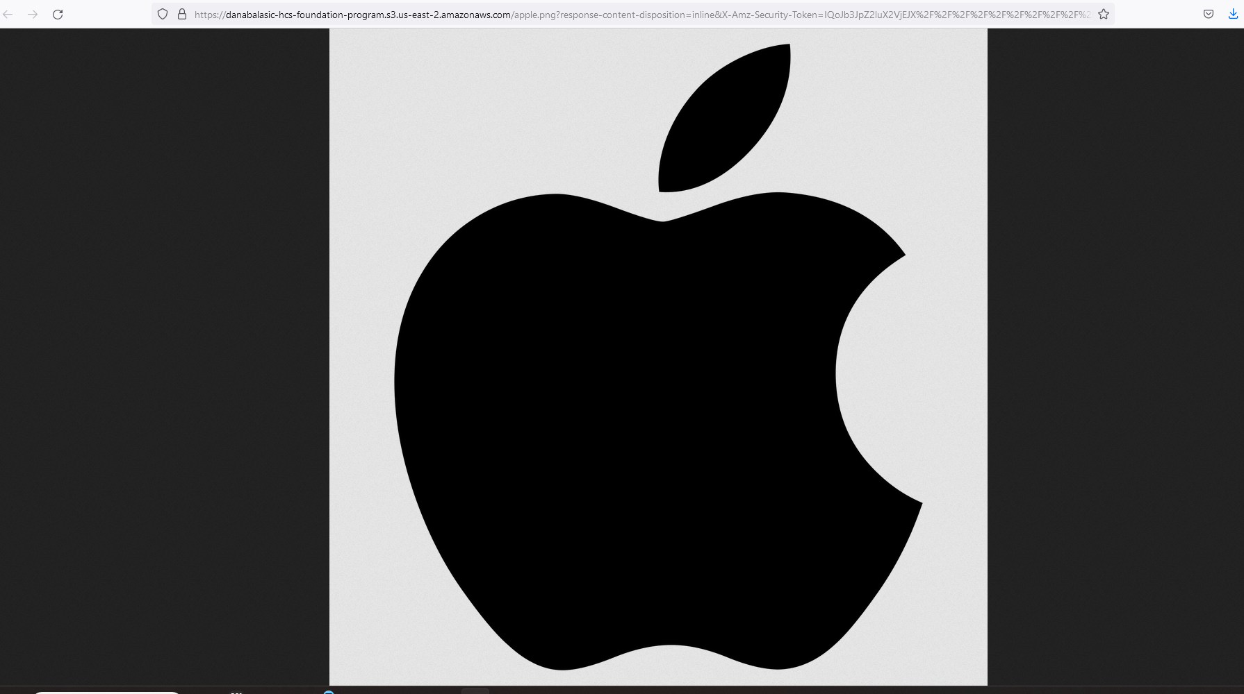

Access for the bucket is blocked, must edit the policies to give access if I want.

## 4.5. Enable Versioning for <yourfullname>-hcs-foundation-program

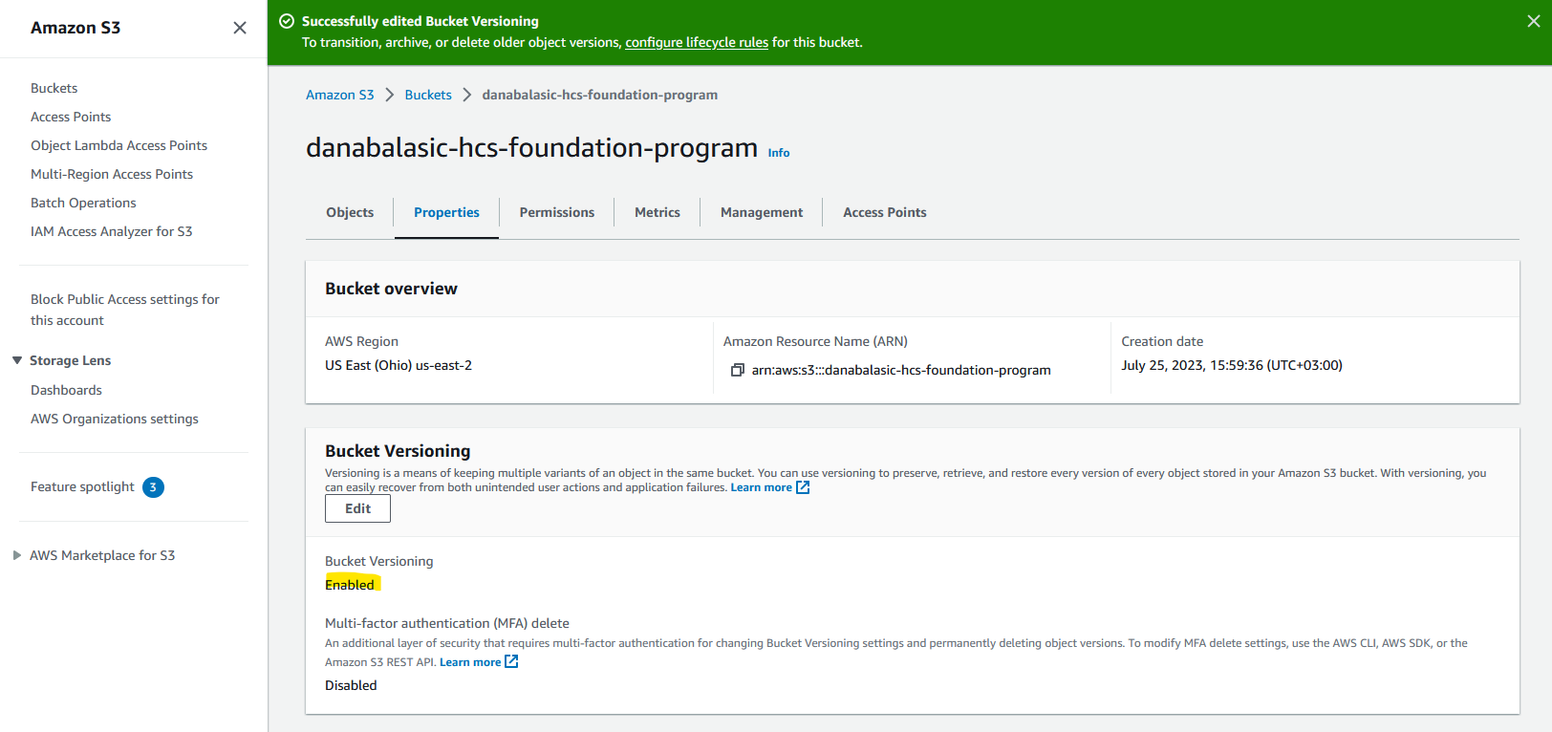

4.6. Download another picture with the APPLE logo (color) and name it apple.png.

## 4.7. Upload the new apple.png file into your bucket.

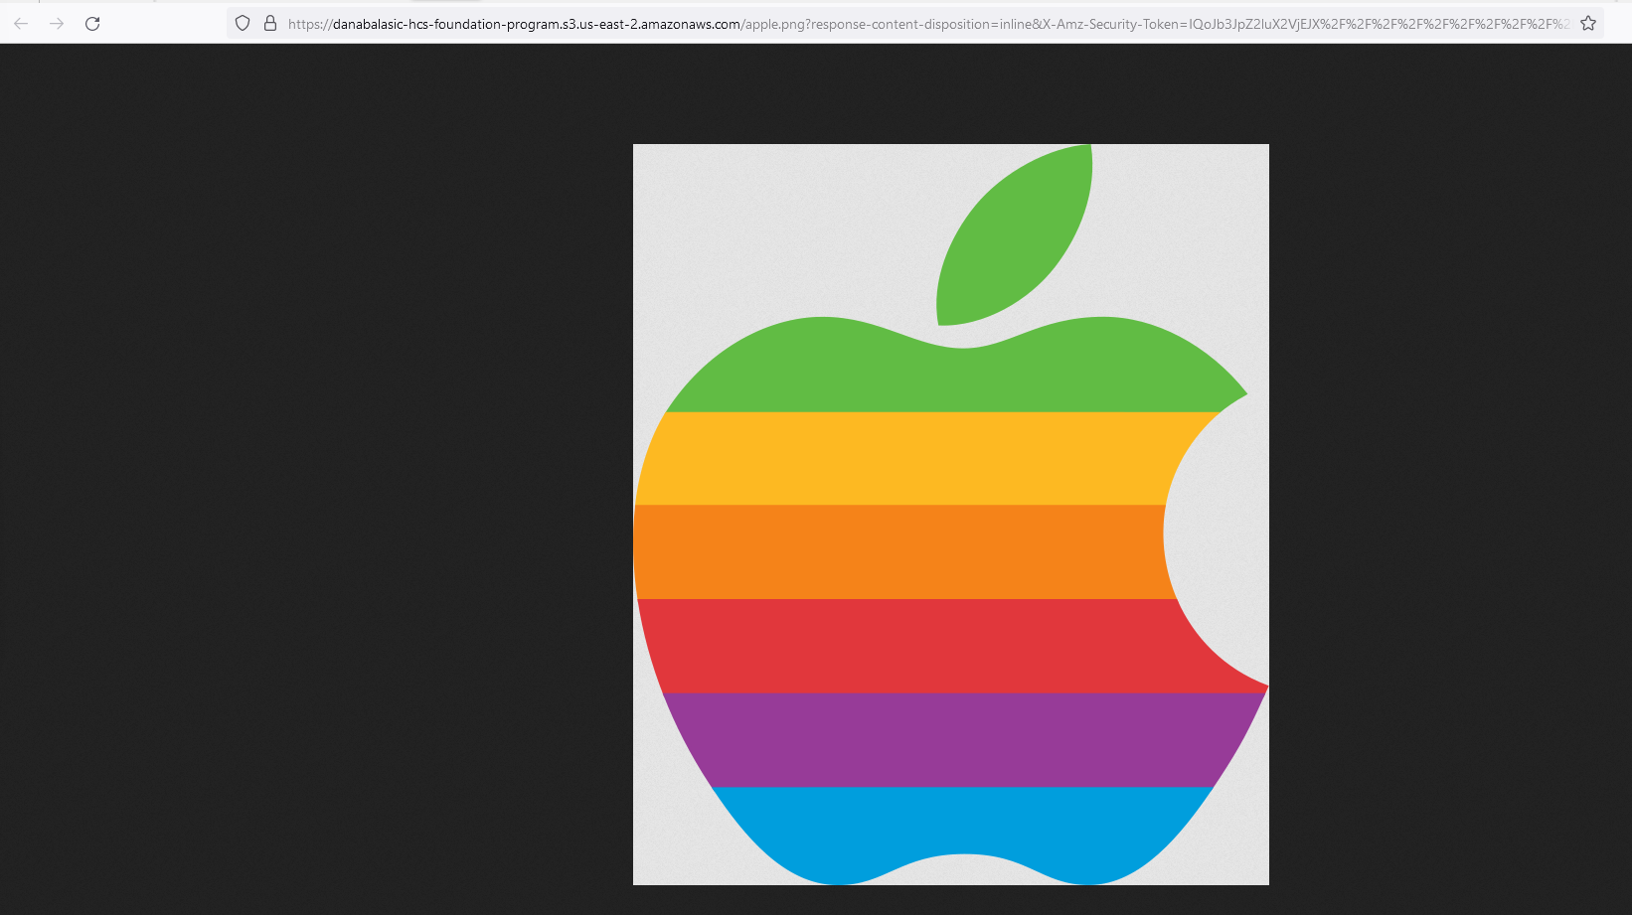

## 4.8. List all the apple.png versions

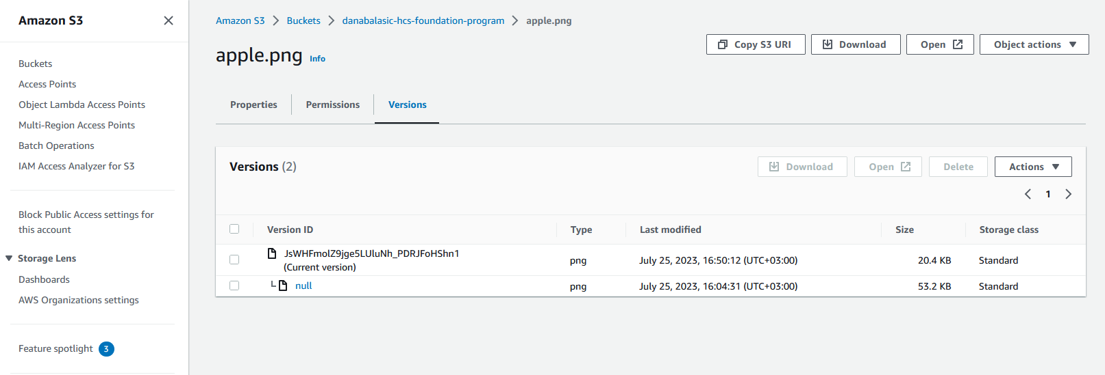

## 4.9. Delete apple.png object (the new object)

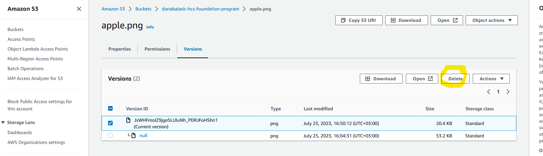

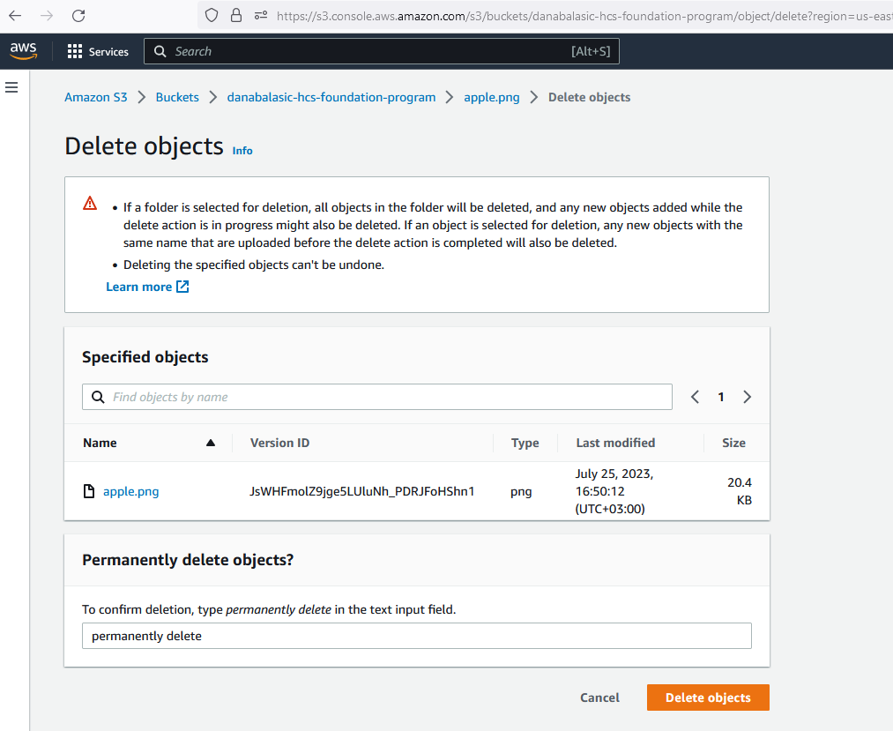

4.10. Expend Versions in order to see if the image has been deleted or not

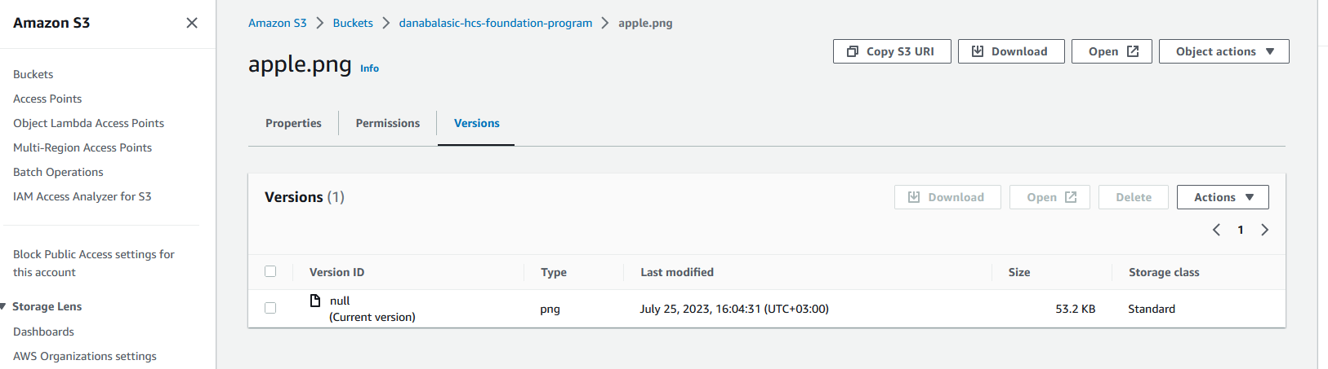

4.11. Restore the old apple.png image (black and white) without re-uploading the image.

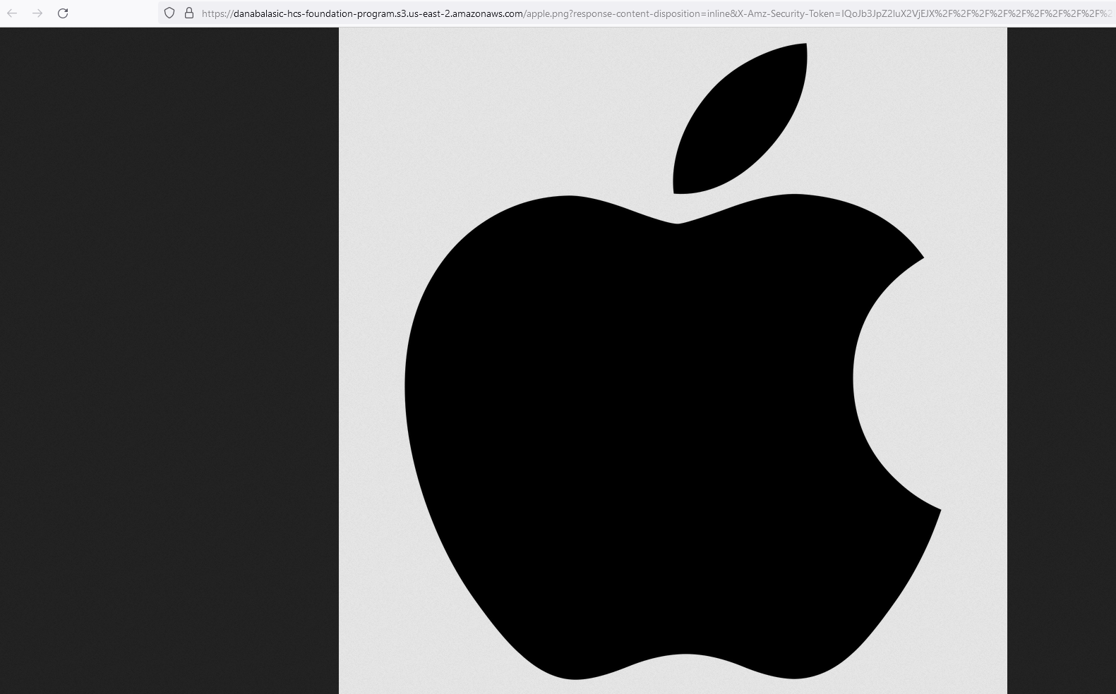

## 4.12. Permanently delete all objects

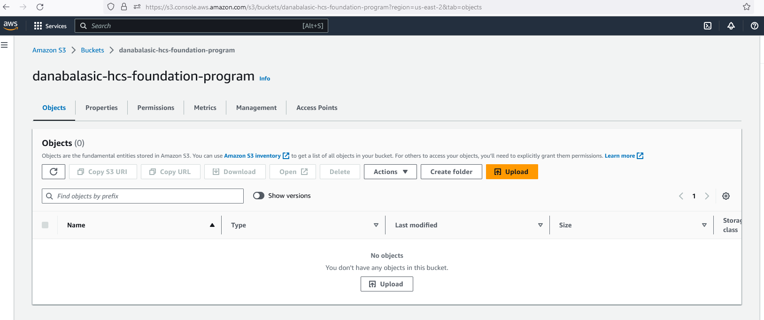

4.13. Enable replication for <yourfullname>-hcs-foundation-program into a new bucket<yourfullname>-hcs-foundation-program-replica

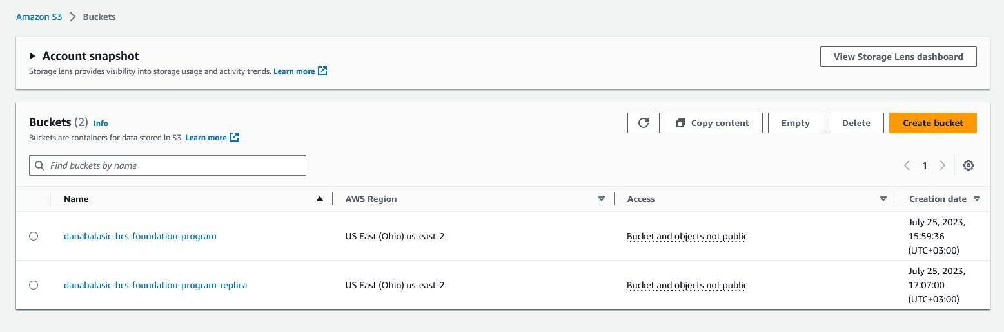

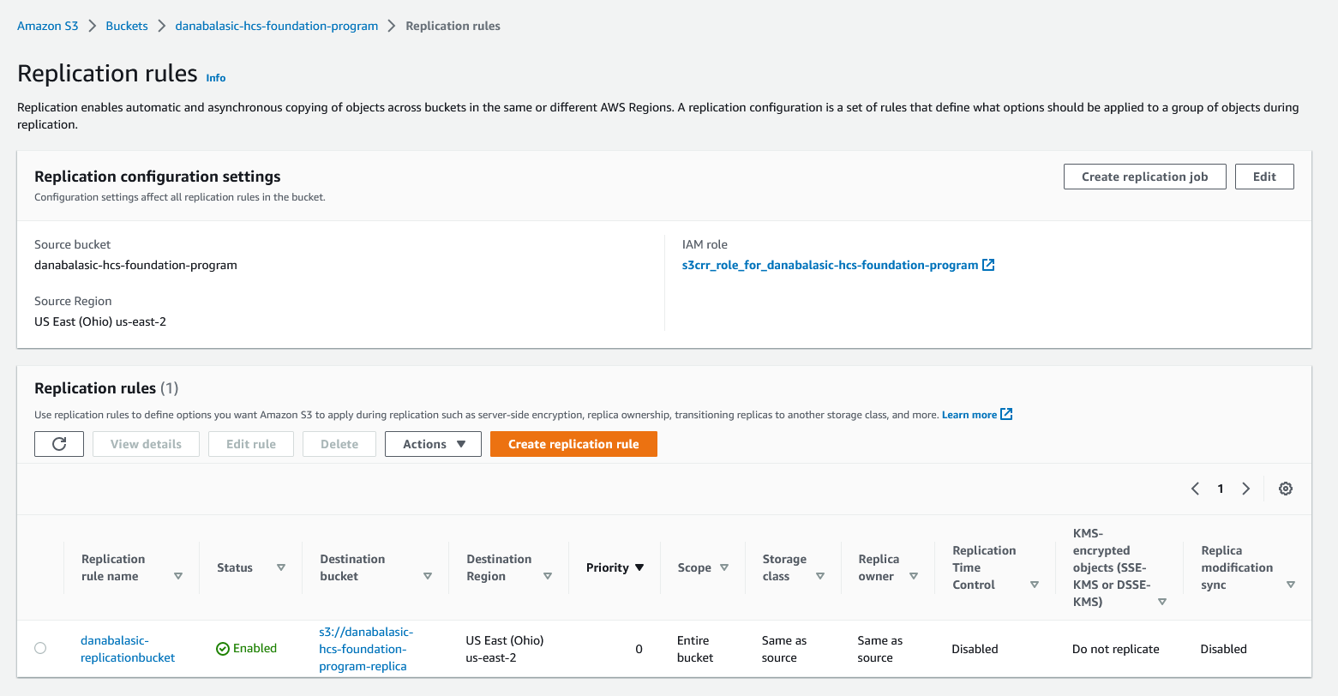

4.14. Download a picture with the IBM logo and name it ibm.png

4.15. Upload ibm.png file into <yourfullname>-hcs-foundation-program and check the replication.

* It appeared after a while

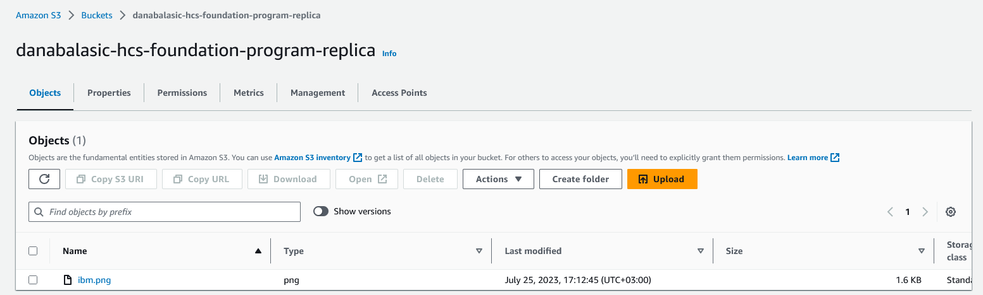

4.16. Create a life cycle policy to move data from Standard Class IA after 30 days, IA to the Glacier after90 days, and expire after 360 days.

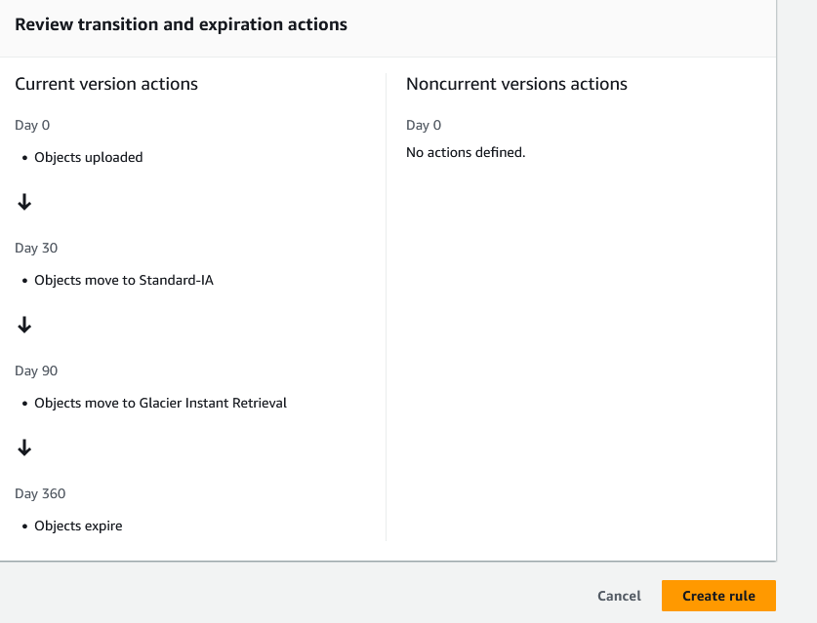

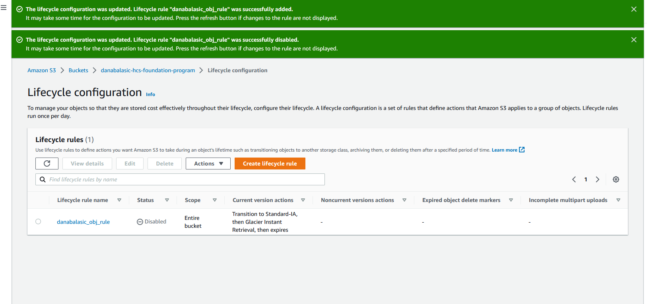

# Amazon EC2

## 6.1 Create three EC2s:

Bastion-Server -> Windows VM [in HCS-Public]

Web-Server -> Linux VM [in HCS-Public]

DB-Server -> Linux VM [in HCS-Private]

So first I should create subnets in my default VPC (10.0.0.0/20)– it doesn’t work because the default VPC is public, I cannot make a subnet private, so I must create a new VPC.

HCS-Public 10.0.1.0/24

HCS-Private 10.0.2.0/24

Created the VPC-Dana in OHIO – us-east-2

https://assistanz.com/creating-vpc-public-private-subnets/index.html

The EC2 instance needs an public IP – an Elastic IP attached available in the zone BUT – I need to enable ICMP as well in SG

<https://stackoverflow.com/questions/21981796/cannot-ping-aws-ec2-instance>

The VPCs:

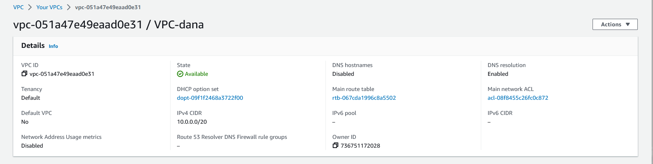

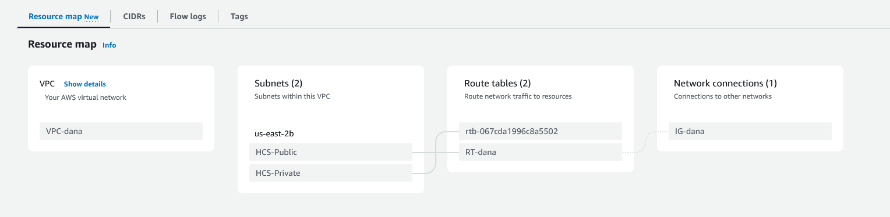

The EC2 Instances:

* Bastion-Server

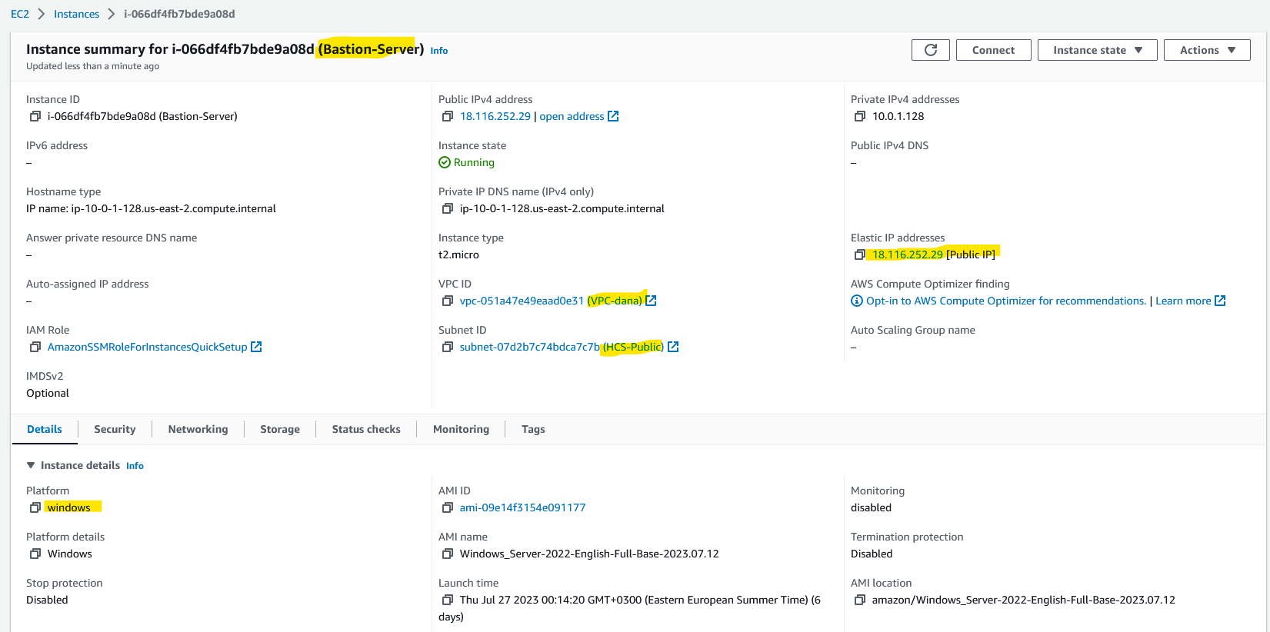

* Web-Server

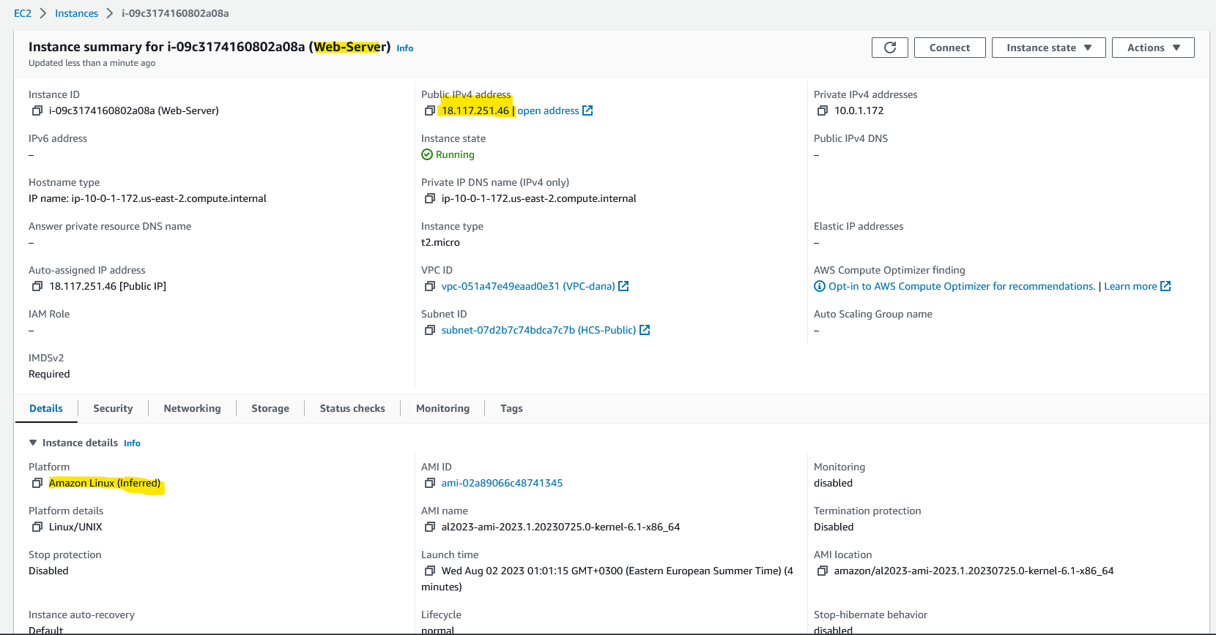

--- after last restart it got public ip: 18.119.101.186

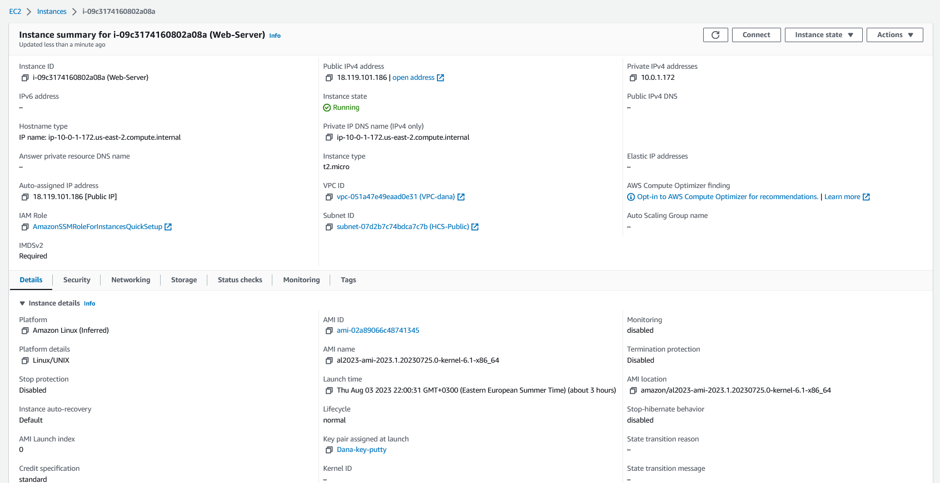

* DB-Server –I realized in the meantime that I configured it very poorly, I attached a bad key file, I attached a public ip, I modified the IAM Role and the SSM so I could no longer connect to the machine… the only way I managed to connect was through AWS SSM but only one time…. Icreated a good one here:

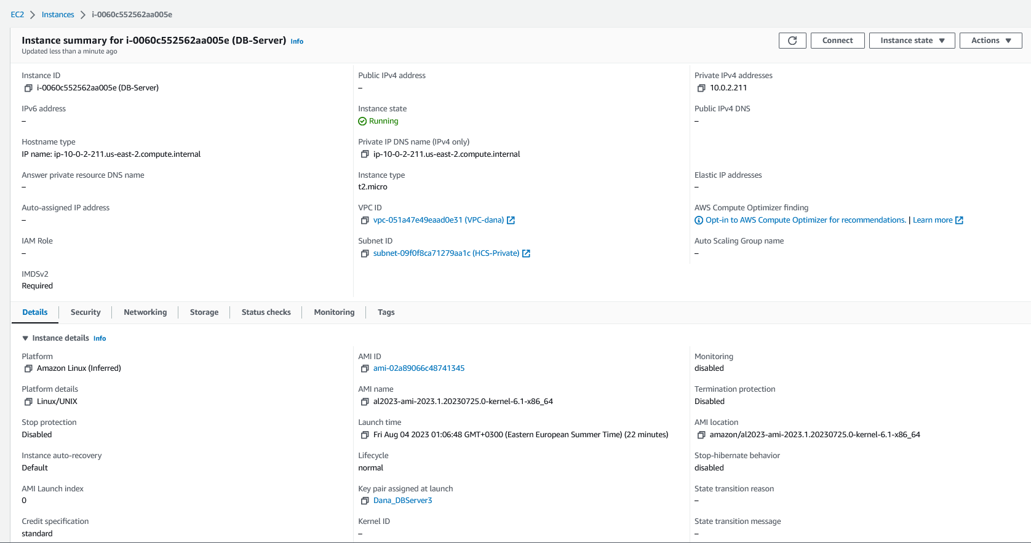

* 1. Are servers reachable? Why? NO, need to modify security group to add an inbound rule to permit echo request ICMP on IPv4

### From your WorkStation ping Bastion-Server - SUCCESS

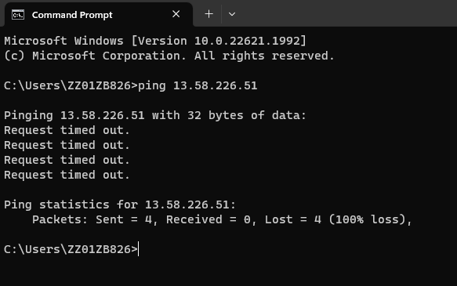

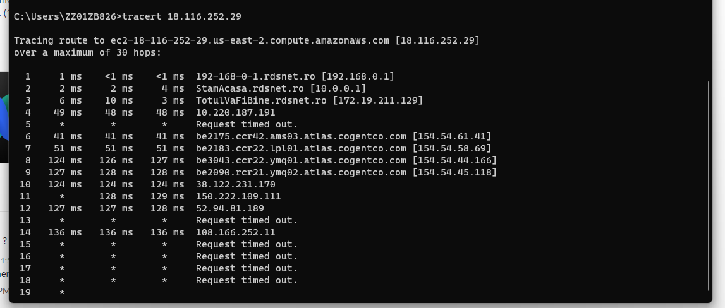

Eventually I did managed to get it to work, only after I managed to fix rdp connection, but I made some modification in the windows firewall of the ec2 instance to allow all inbound and outbound ICMP for IP4 traffic.

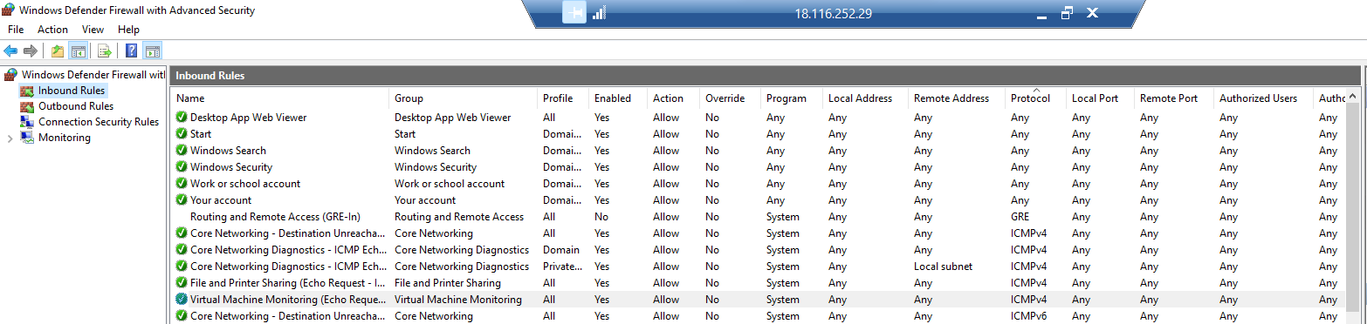

My guess is that by modifying the ‘File and Printer Sharing’ inbound rule, it got fixed.

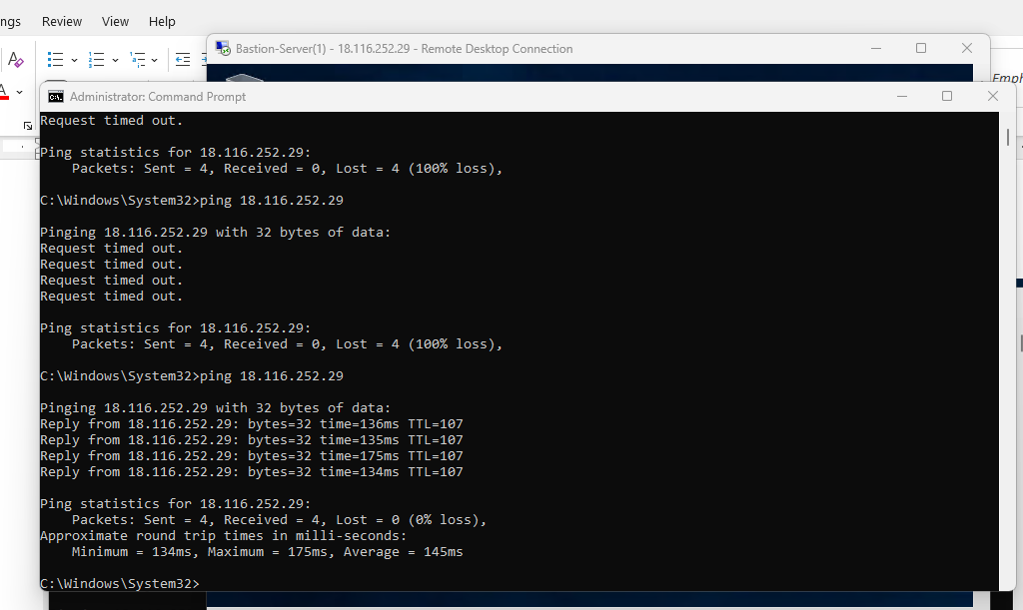

### From your WorkStation ping Web-Server - SUCCESS

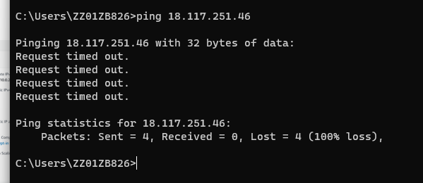

I finally got it working, I tried to modify the firewall in Amazon Linux 2023 – but it has none… eventually I edited the inbound rule to receive all traffic on ICMP:

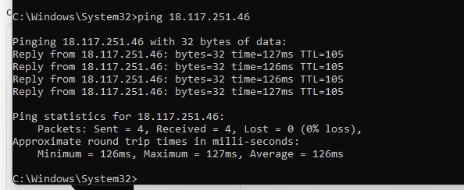

### From your WorkStation ping DB-Server -FAIL? NOOO

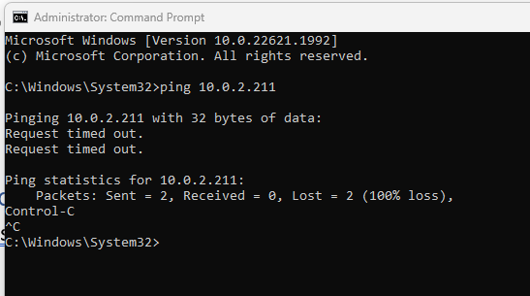

I do not expect it to be pingable from my workstation, because it is in a private subnet, with a private ip. As for security rules it uses the same as Web-Server: launch-wizard-2.

* 1. Are servers accessible? Why? No – they need security group rule to permit ssh for linux and rdp for windows

### Connect to Bastion-Server -SUCCESS

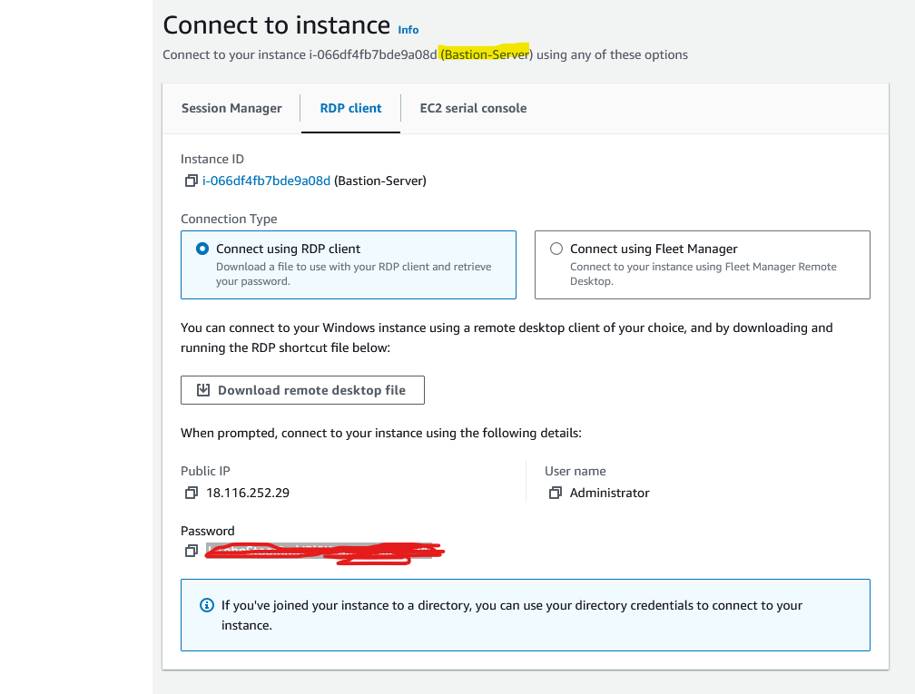

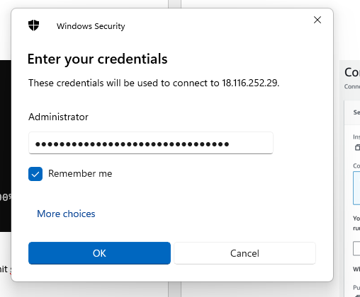

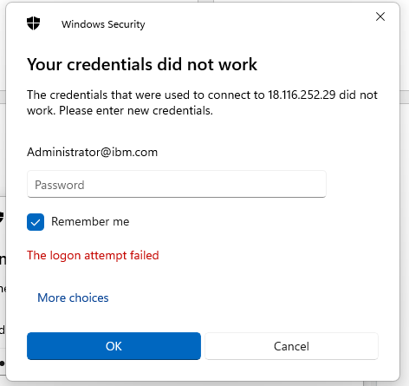

I do not know why it adds ‘@ibm.com’ at the end of Administrator; connection through AWS System Manager works

UPDATE!!!!!!!!!

Managed to make it work with the user \Administrator; the blank in front is because the machine is missing hostname.

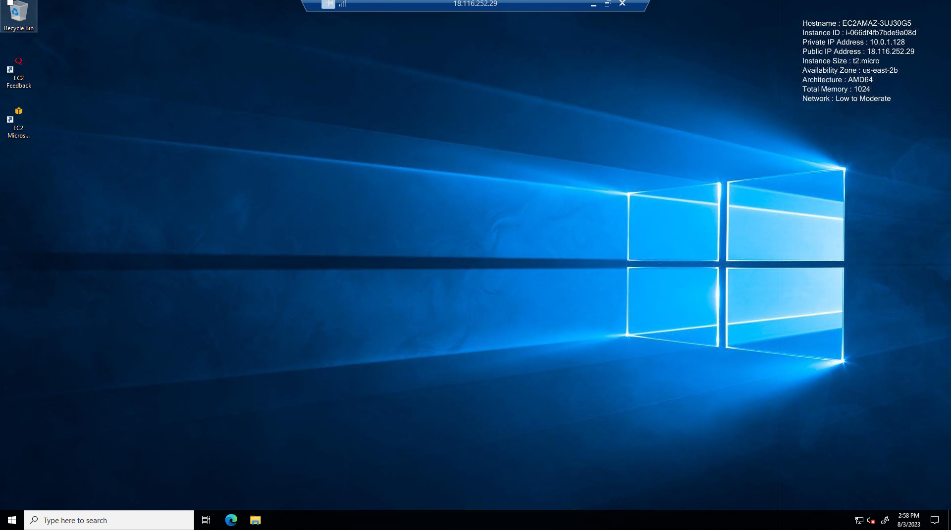

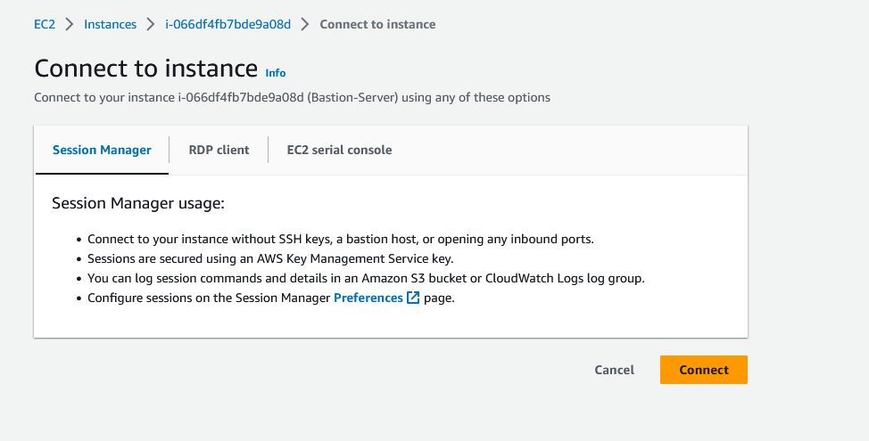

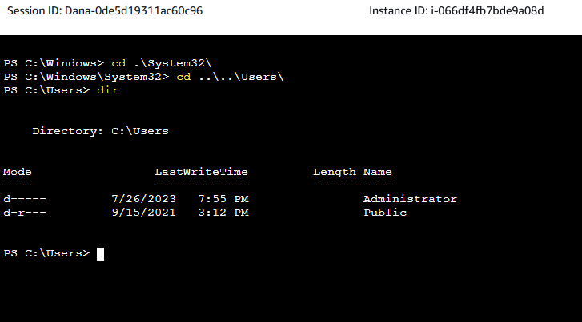

On ipconfig it has only the private address:

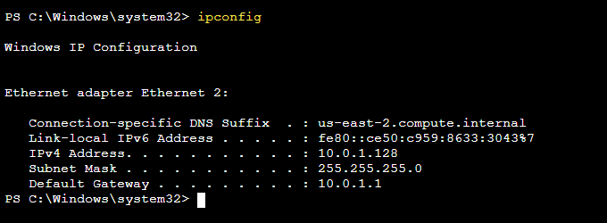

The security rules on this ec2 instance:

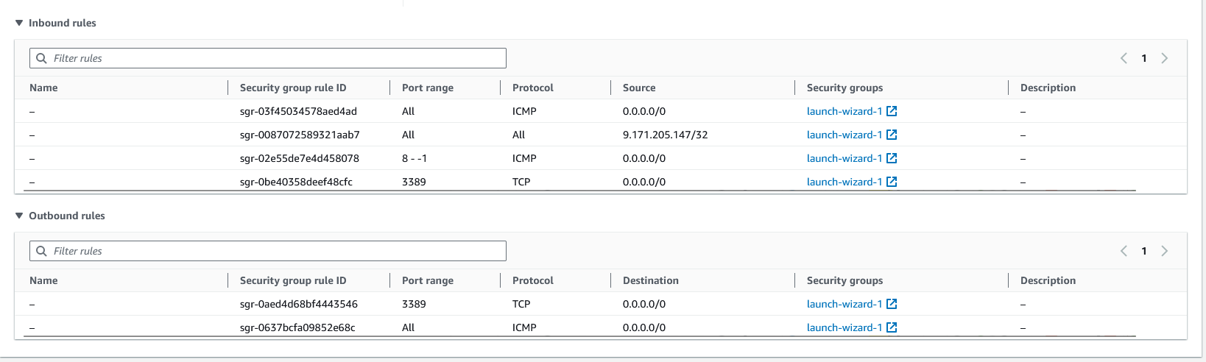

### Connect to Web-Server - SUCCESS

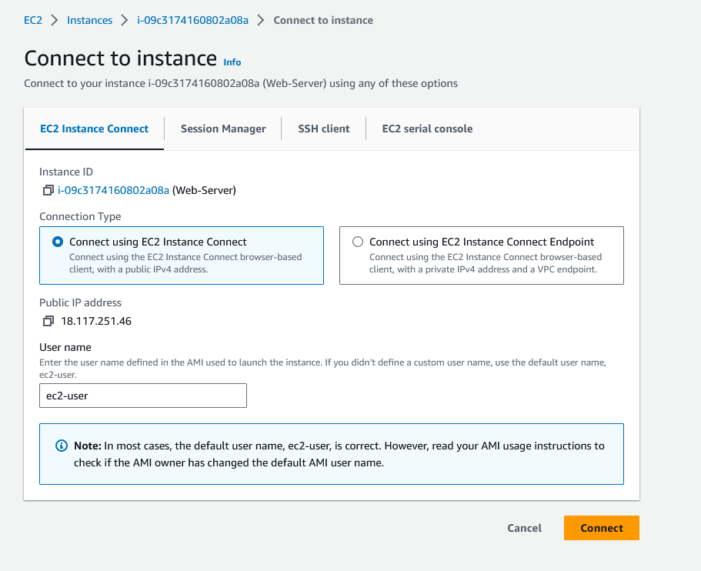

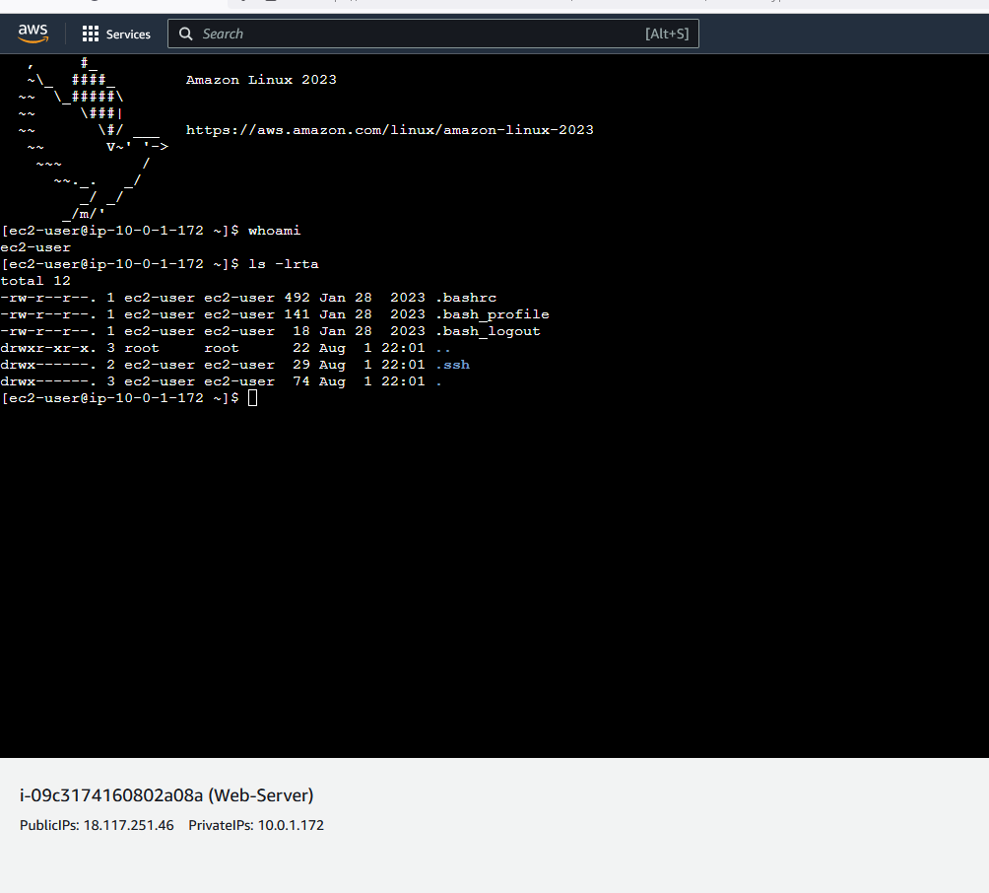

Also works through putty:

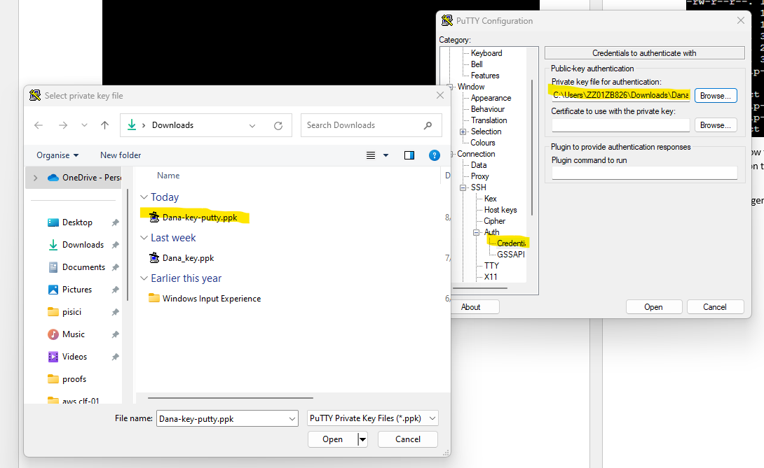

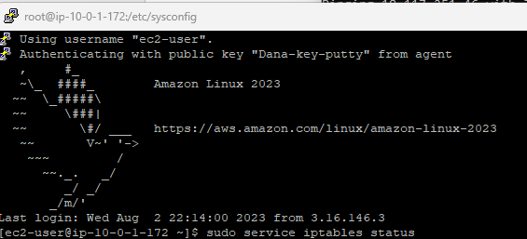

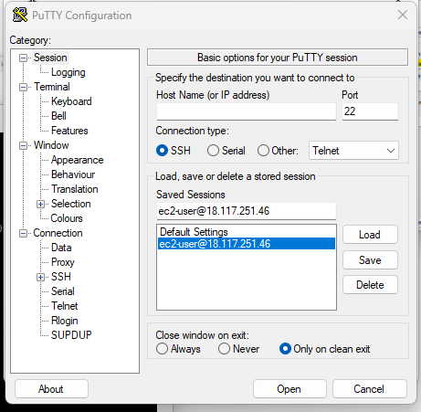

### Connect to DB-Server from Web-Server – SUCCESS

* I connected to Web-Server, added the key for DB-Server through Winscp and managed to connect:

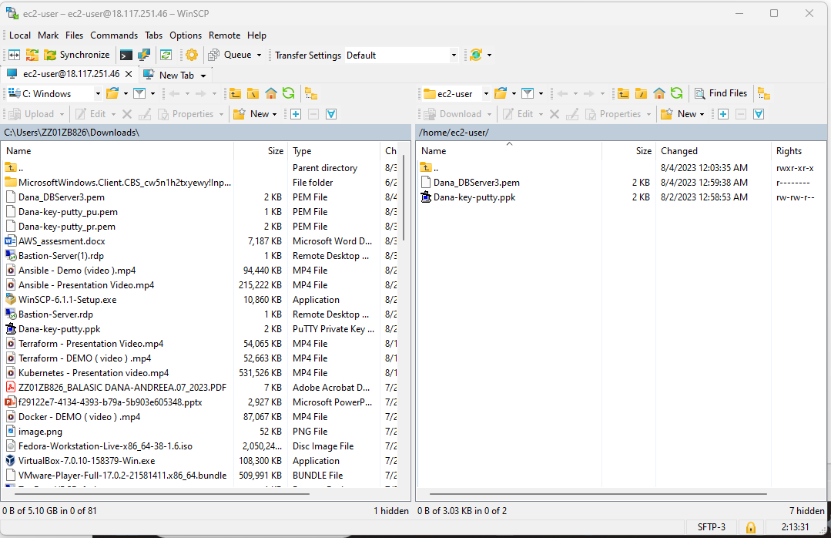

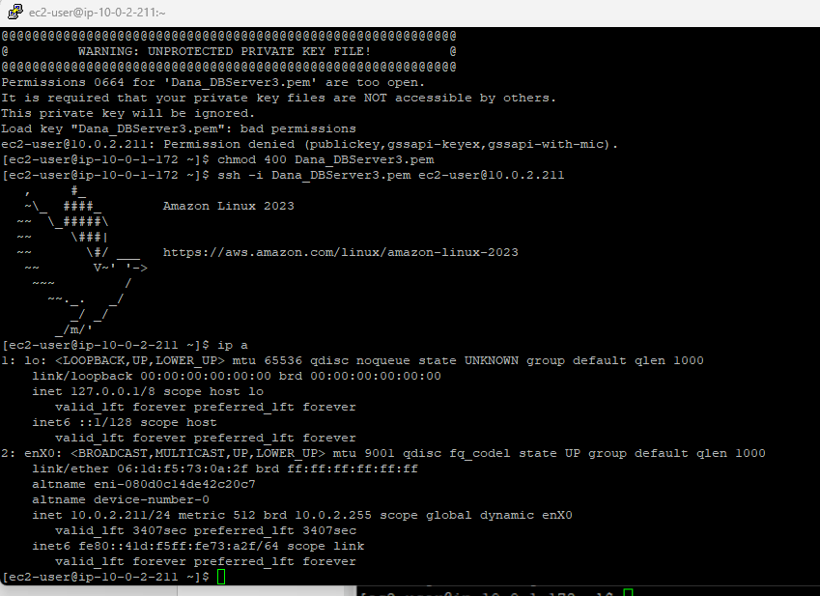

## 6.4 Reconfigure the SGs :

Allow SSH for Linux VMs,

Allow RDP for Windows VM and

Allow ICMP – IPv4 from Anywhere [Linux and Windows VMs]

Inbound rules are for incoming traffic

Outbound rules are for outgoing traffic

### For bastion-server

* + Incoming: rdp, icmp
  + Out: icmp, rdp

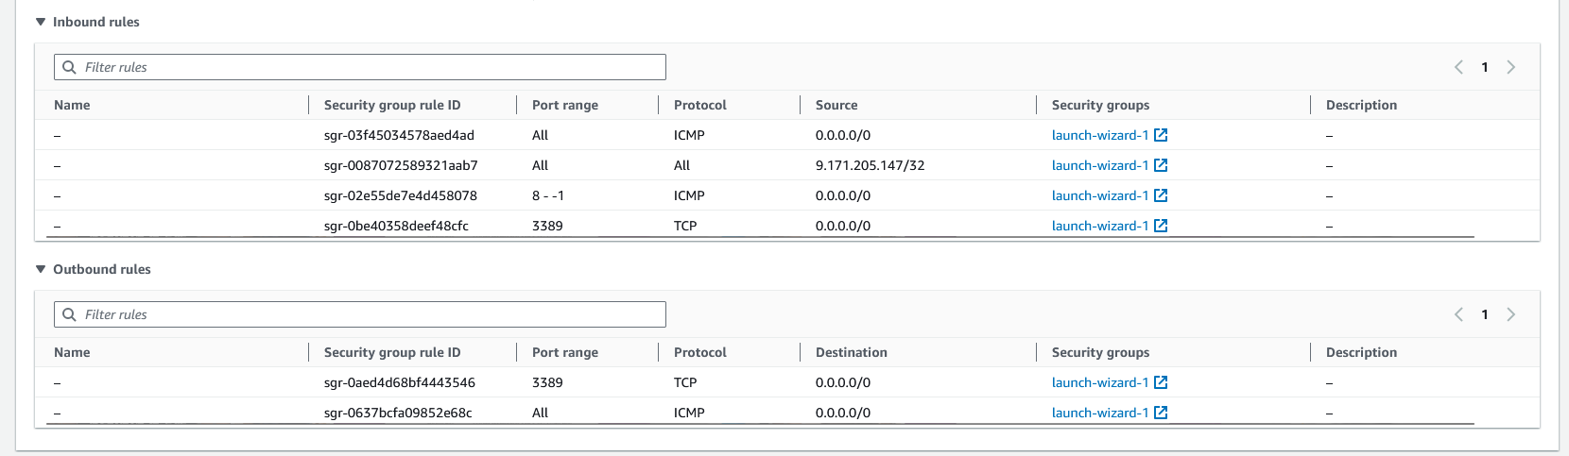

Connection through RDP works now!

### For Web-server

* + In: ssh, icmp
  + Out: ssh – so I can access db-server, icmp

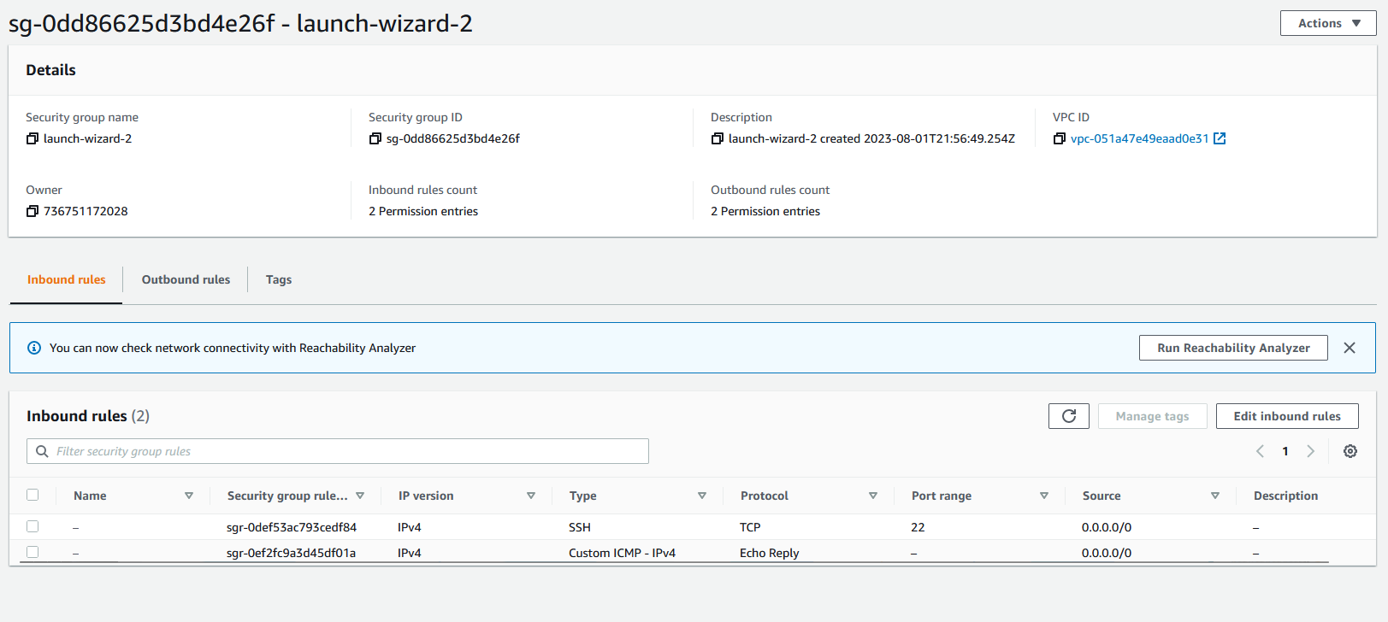

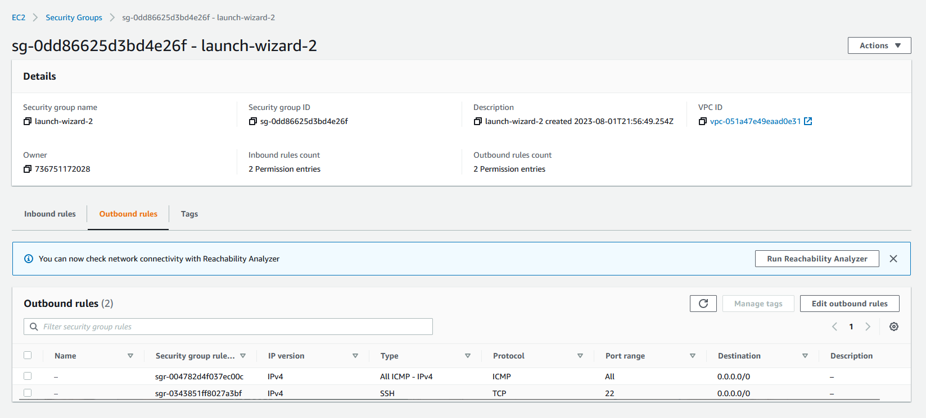

### For DB-Server:

* + In: ssh, icmp
  + Out: ssh, icmp
* Used launch-wizard-2 here as well; connection to it directly doesn’t work, but that should be ok because is on a private VPC

## 6.5 Retry all the PINGs and Connections:

### From Bastion-Server ping Web-Server - SUCCESS

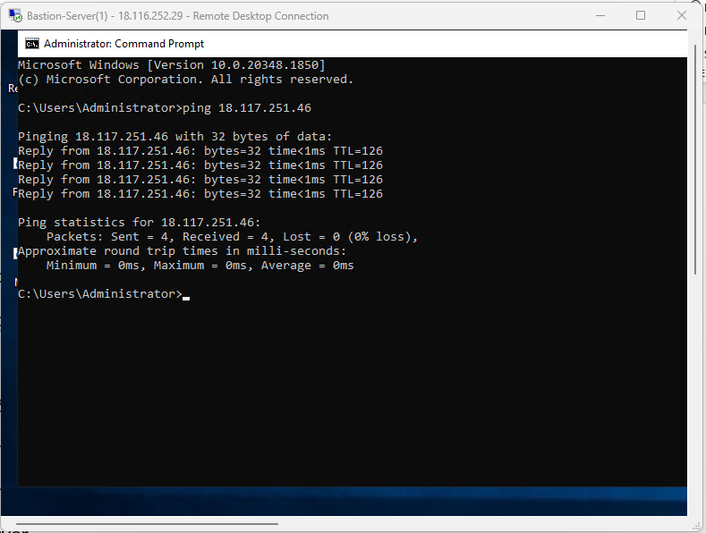

### From Bastion-Server ping DB-Server – SUCCESS

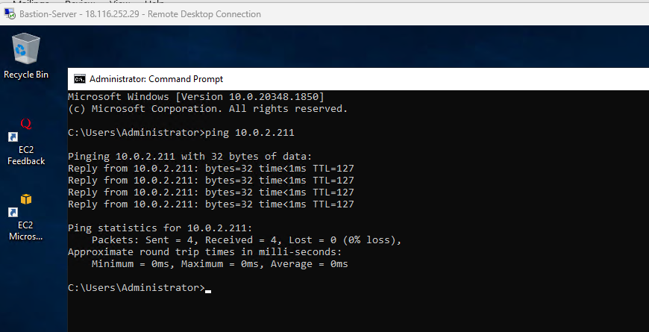

### From Web-Server ping Bastion-Server -SUCCESS

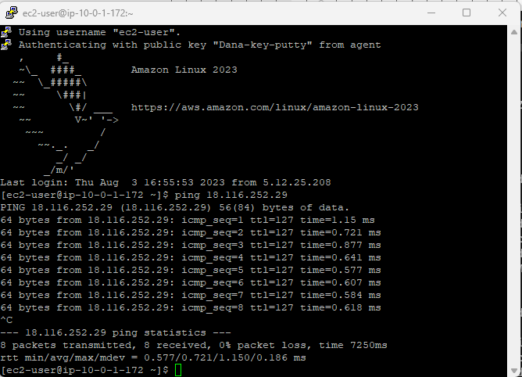

### From Web-Server ping DB-Server -SUCCESS

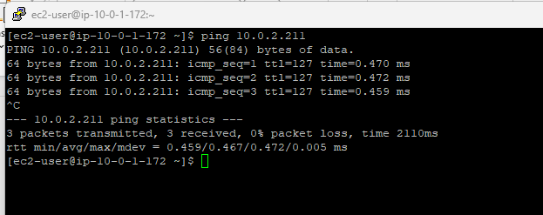

### From DB-Server ping Web-Server – SUCCESS

I can ping the private ip of Web-Server but not the public ip.

ssh -i Dana_DBServer3.pem [ec2-user@10.0.2.211](mailto:ec2-user@10.0.2.211)

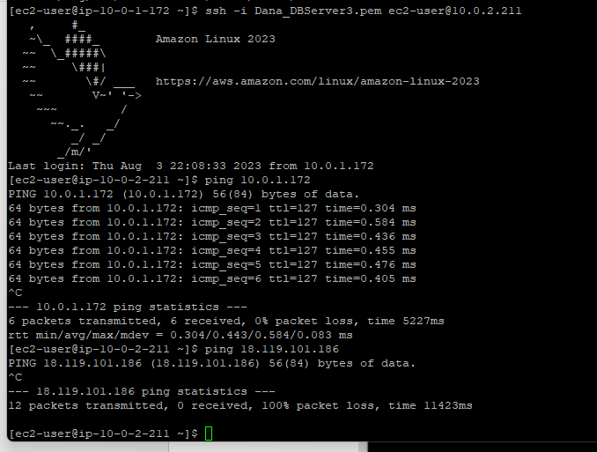

### From DB-Server ping Bastion-Server - SUCCESS

Same as with Web-Server, I can ping the private address, I could narrow it down if I want from SG.

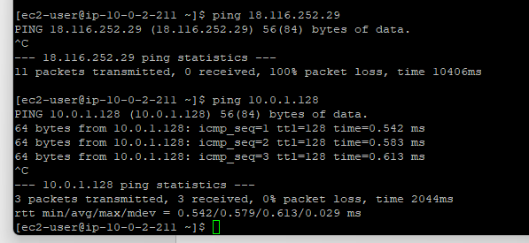

### Ping www. google.com from Bastion-Server – SUCCESS

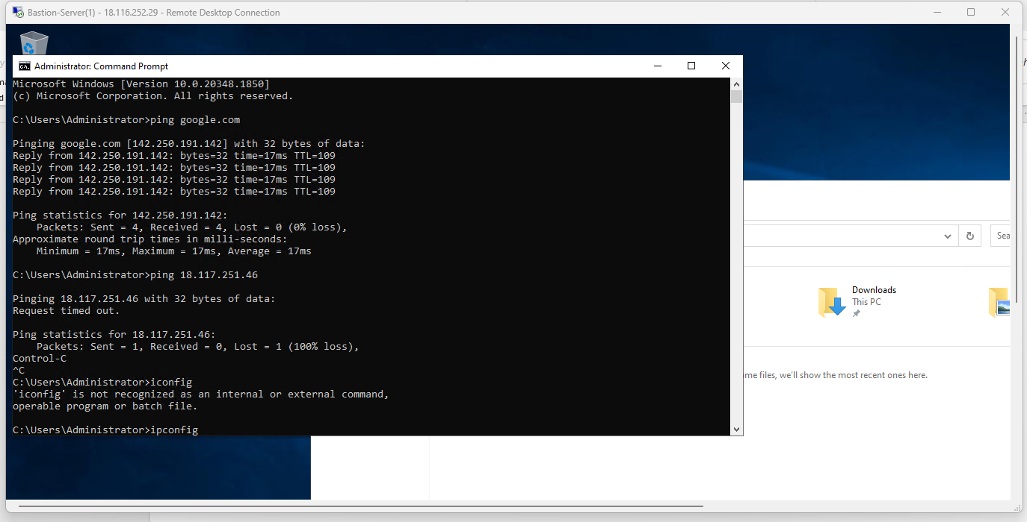

### Ping www.google.com from Web-Server - SUCCESS

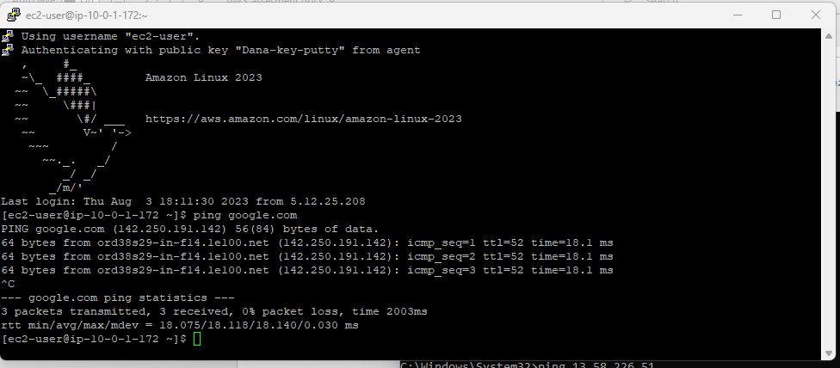

### Ping www.google.com from DB-Server – SUCCESS

* There is no communication with the internet, as expected.

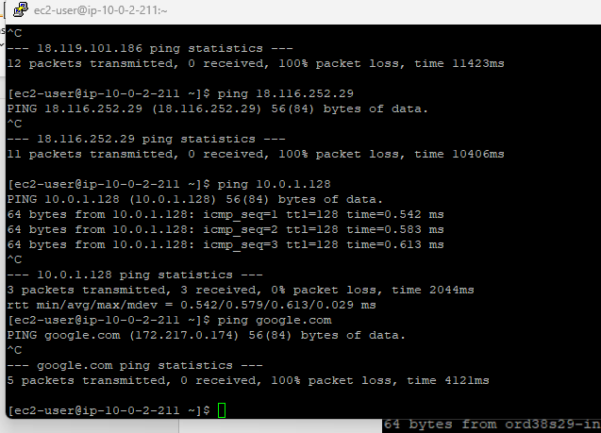

# 7. Cloud Watch

7.1. Create a CloudWatch Alarm for Bastion-Server, in order to generate an alarm (email) for Network Packets IN > 100.

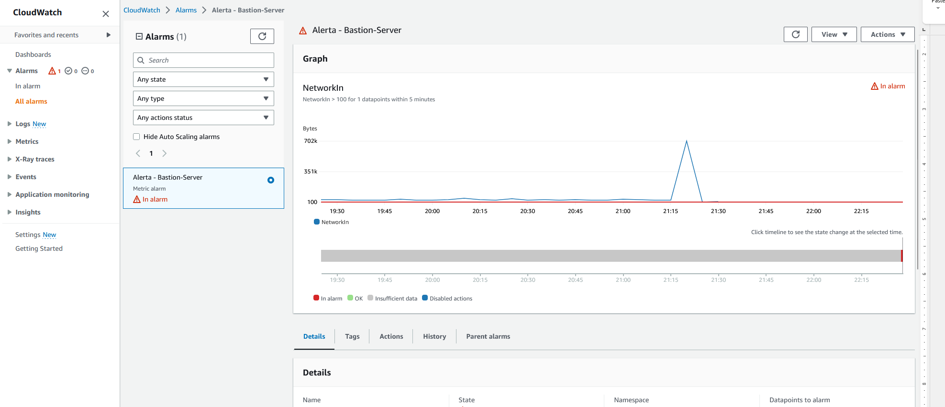

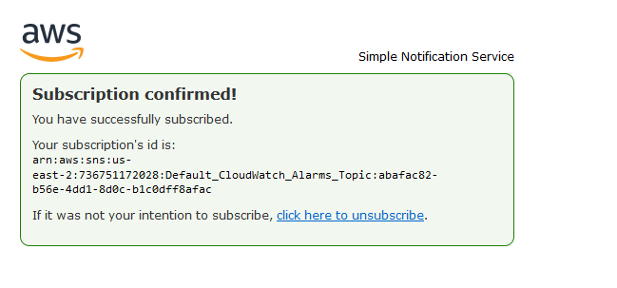

## 7.2. Generate some traffic in order to trigger the alarm.

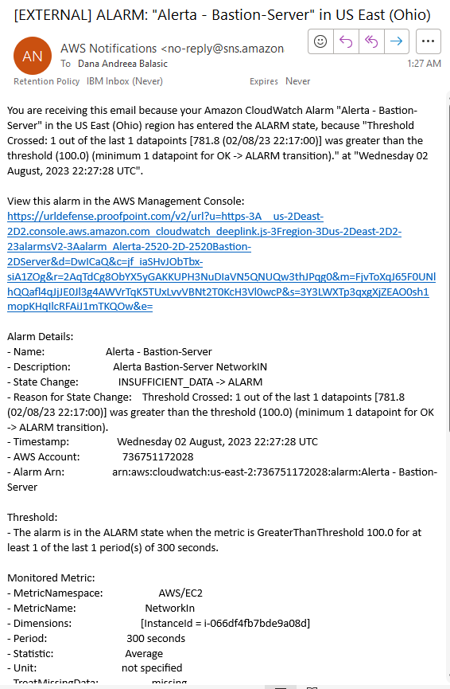

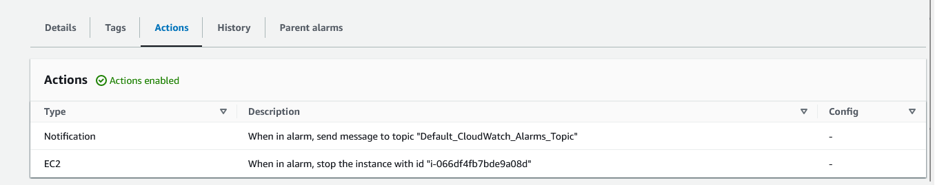

It stopped

